Name:  Teacher : | ____________________________________  ______________________ |  | Date:_________
 | Year 10 General  SCORE:  / 35  Mini Test 8  Topic – Bivariate Data  Full working out MUST be shown to get full marks for each question.
Total Time: | 35 minutes + 1 min reading
Weighting: | 4%
Equipment: | To be provided by the student: Pen, pencil, ruler, scientific calculator, 1 single sided page of A4 notes

Question 1 6 marks

Identify the shape and direction of the following scatterplots

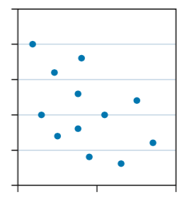 | a.___________________________________
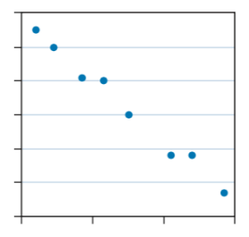 | b.___________________________________
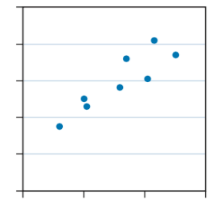 | c. ____________________________________

Question 2 2 marks

Identify the independent and dependent variable of the following pairs of bivariate data.
- Hours slept and achieved test results

- Price and average distance run in sneakers

Question 3 9 marks

Complete the table below by indicating whether or not you think there is a relationship between the pairs of variables and, if you think there is a relationship, sketch what you think a graph of the variables might look like. Describe the strength of the relationship.

Variables | Do you think there is a relationship? | Scatterplot | Strength of the relationship
Person’s height

Person’s IQ
Temperature in fridge

Time before food goes bad
Level of education

Income

Question 4 6 marks (1, 1, 1, 1, 2)

Data was collected to investigate whether the outside temperature is related to the number of people preferring to spend time in a recreation room at an island resort. Below is a scatter plot of this data.

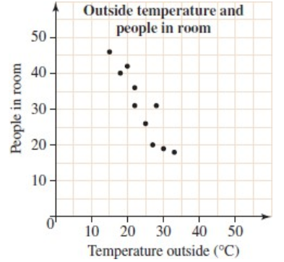

- Draw the line of best fit.

- Use the line of best fit to predict:
  - the temperature outside when 22 people are in the room

  - the number of people in the room when the outside temperature is 17 °

  - the number of people in the room when the outside temperature is 50 °C.

- What advice would you give the management regarding the use of the room?

Question 5 12 marks ( 5, 1, 2, 2, 2)

Q5) A statistician was asked to investigate whether countries with higher levels of consumption of a particular foodstuff tended to have a higher death rate due to heart disease. The following information was obtained for 12 countries.
 | CONSUMPTION OF FOODSTUFF  kg per person per year | DEATHS DUES TO HEART DISEASE  Per year per 100 000 of population
Country A | 57 | 299
Country B | 13 | 154
Country C | 51 | 152
Country D | 48 | 295
Country E | 35 | 208
Country F | 9 | 100
Country G | 21 | 175
Country H | 10 | 120
Country I | 46 | 202
Country J | 64 | 290
Country K | 38 | 156
Country L | 29 | 250


- Draw a scatterplot on the axis below.

- Fit a trend line by eye to the data

- Describe the strength and direction of the relationship between these two variables.

- Are there any outliers in this set of data? How could you tell?

- A person looking at this data says that a country where people eat 50kg’s of food would have 250,000 deaths in a year. Does this seem reasonable. Explain your answer?

~END OF TEST~

